Pre-University Activities (Sohaib Qamar Sheikh, Coordinator)
- Teacher In-Service Program (TISP)
- A TISP workshop was successfully organized on March 21, 2012 in Toulon-Var University, Toulon, France. The workshop was organized by the IEEE Tunisia section, IEEE Education Society (ES) Tunisia chapter, the HANDIBIO laboratory, and participants of the 2nd Tunisian TISP Workshop in cooperation with the Research Groups on Intelligent Machines (REGIM Lab.), the IEEE Region 8 Educational Activities Subcommittee, and the IEEE Educational Activities Board (EAB). The workshop had 24 participants and received excellent feedback.
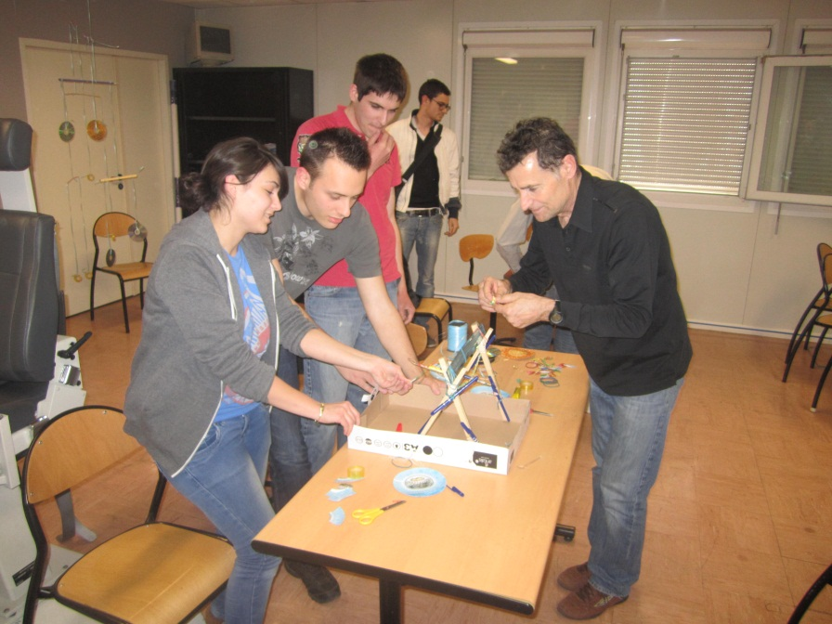
- A 3-hour TISP workshop is being organized during the R8 Student Branch Congress being held in Madrid, Spain from 25-29 July, 2012. The workshop is part of the Education Track at the congress which is completely being coordinated by the Pre-University Works Committee (PUW).

- TISP Workshop requests have been received from the UAE Section, Ministry of Education, Bahrain, and for the ME-SBC due to be held in Lebanon next year. All requests have been forwarded to the EAB staff to initiate preparatory teleconferences.

- Engineering Projects In Community Service (EPICS)
- An EPICS application was submitted by the GJU Student Branch, Jordan in April, 2012.

- EPICS applications for projects in Sweden and Palestine are complete and will be submitted in the next month.

- An E-notice regarding the program is in the process of being sent to all R8 members with the help of EPICS High Administrator. The aim of the E-notice is to make members in our region aware of this program.

- Webinar Series
The webinar series continues as planned:
- PUW organized a webinar on TISP in April, 2012 which received favorable response. We were also a part of the global EPICS-in-IEEE webinar organized in May, 2012. Both webinars had more than 20 participants.

- Webinars on our Education portals and Humanitarian activities will be organized in August and October respectively.

- Outreach Efforts
PUW committee has continued its outreach efforts with events and direct member outreach.
- As mentioned in the report earlier, an EPICS E-notice has been dispatched to all IEEE members in Region 8.

- To increase social media outreach, we have created facebook and twitter pages, and are maintaining them actively.

- An outreach event was organized at the Jordanian SBC to reach out to the student members in the section. This action resulted in one EPICS application being sent from the section. Our Middle East Coordinator, Muhammad Mustafa, can been seen in the picture below presenting about our programs to the participants.
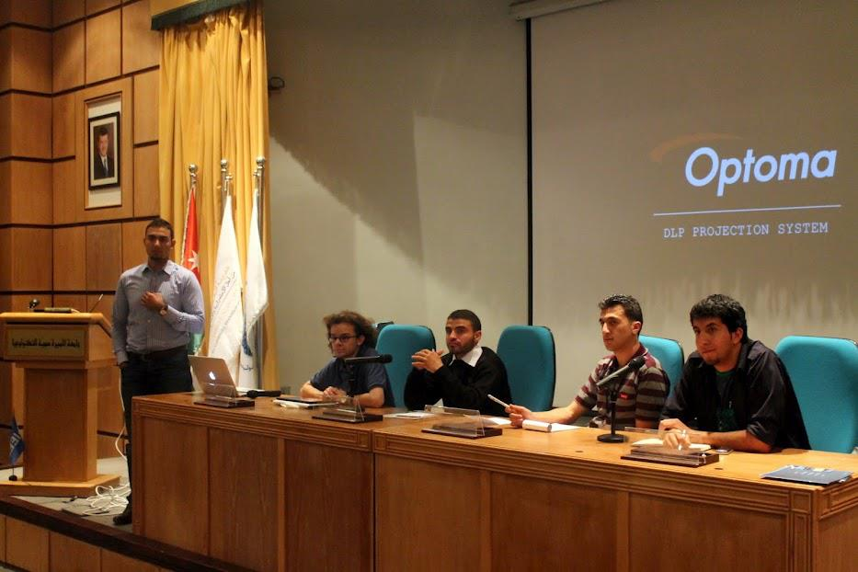

- PUW organized an event called 'Why Engineering?' for 50 students from few of the most prestigious schools in UK including Eton College, Langley Academy, Beechwood School and Slough & Eton College on June 26, 2012. The talk was followed by a competition where teams of students had to build a Robot Arm from regular craft supplies. The robot arm lesson was taken from TryEngineering.org where more than a 100 different lessons are available to make learning more practical and fun for students. This session was kindly sponsored by R8 Technical Activities and Slough & Eton College.

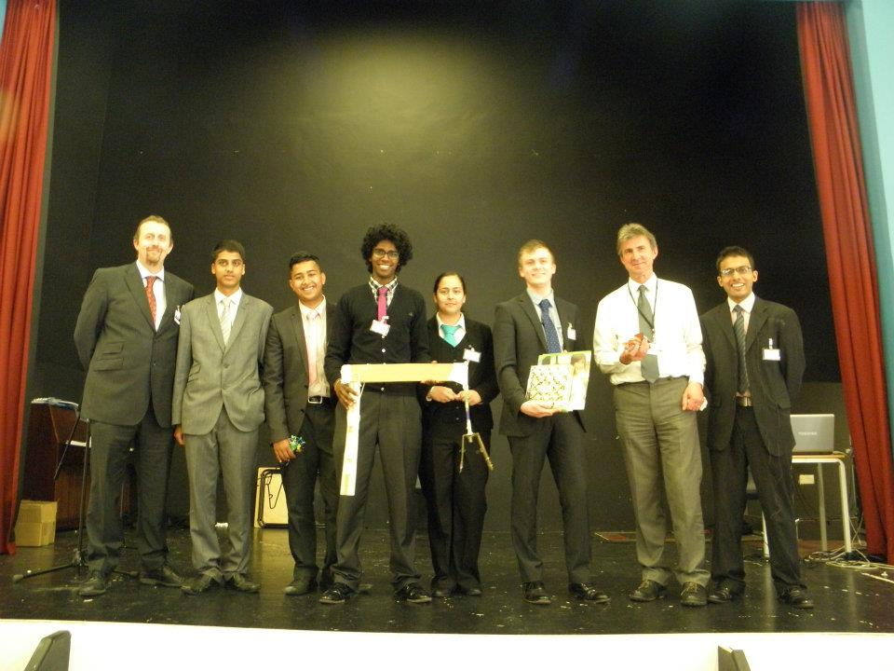 | 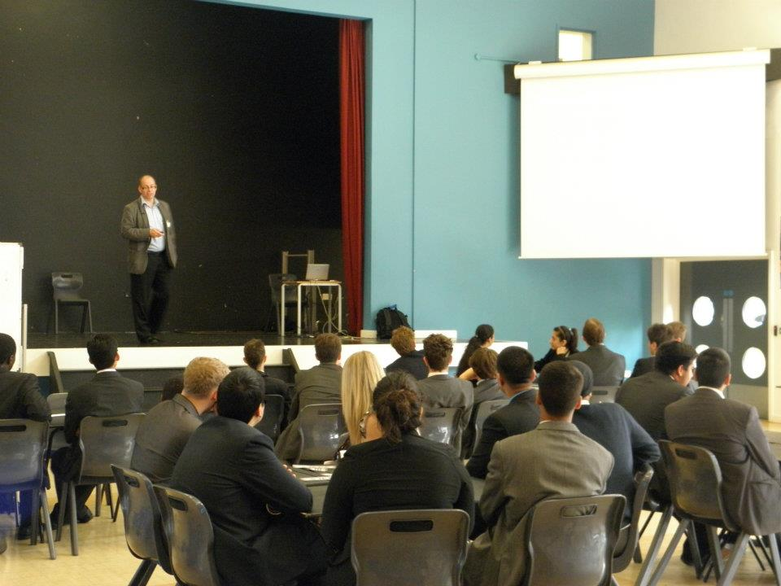
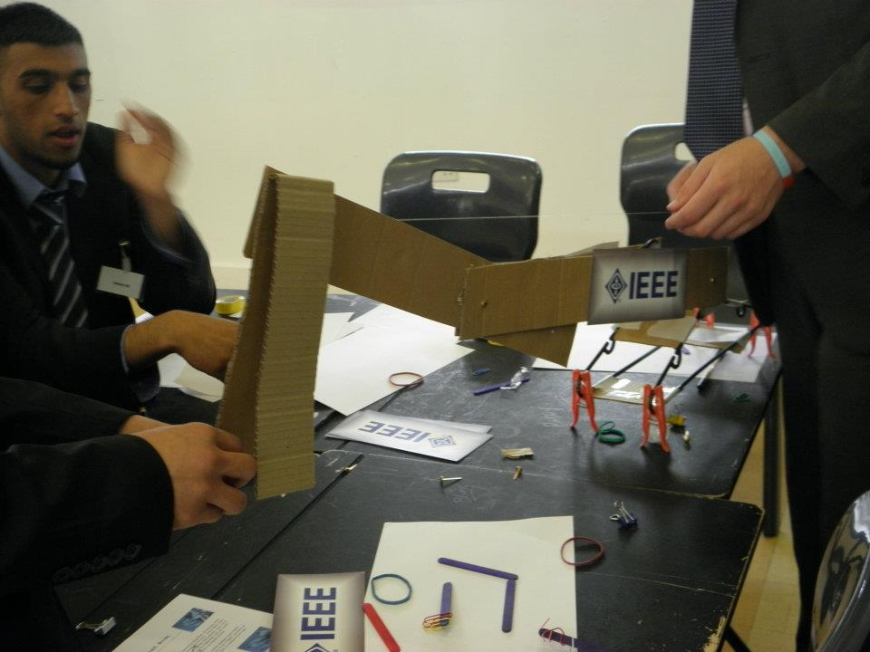 | 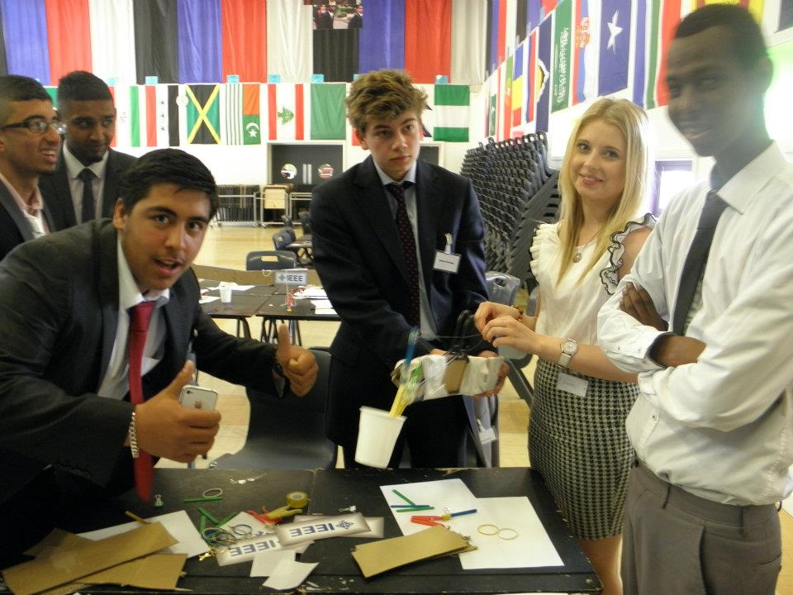

- IEEE R8 Student Branch Congress, 2012
PUW is completely responsible for organizing the Education Track and two non-technical workshops at the congress due to be held in Madrid, Spain from 25-29 July, 2012.
Below are the details of the workshops,
Education Track:
- Teacher In-Service Program – A 3 hour long workshop is organized for 30 participants and includes 3 components
  - Pre-University Activities overview by Liz Burd, Chair PECC.
  - TISP lesson on tall tower by Fabio Domingos, IST Student Branch TISP team
  - Pre-University R8 Focus and Updates by Sohaib Qamar Sheikh, R8 Pre-University Coordinator

- Contributing for education innovation: The fall of the chalkboard – A 1.5 hour workshop on a new project by Rui Costa from the IST student branch which aims to provide students with a new methodology to study more effectively through videos and online exercises. Details about this project can be accessed at http://82.102.6.169/~academic/en. The website is currently a prototype and will be launched completely during the congress.

- Engineering for Change – A 1.5 hour workshop by Adrian Pais, VC Humanitarian Activities on how students can get involved in social projects to increase their practical knowledge and contribute to their society.

- TryComputing,org Session – A 15 min session sponsored by IEEE CS to advertise the TryComputing portal and their education related programs.
Non-Technical Workshops:

- Two 1.5 hour long workshops on EPICS will be delivered by Moshe Kam and Sohaib Qamar Sheikh. PUW Coordinator for Africa, Joyce Mwangama will also be present to give a case study of an EPICS program she was involved with in the past.

